**DBQCS**

You can manage metadata you want to use as well as the quality when designing and modeling a database.

**Managing DB Quality Assurance**

Following is how to manage the DB metadata standard and how to improve quality and function with DBQCS Services:

1. Managing Metadata
   1. Dictionary
      1. Manages standard terminology, standard word, standard domain, banned word, subject area, etc.
      2. You can make a request to change metadata with “Create New” button.
      3. Standard terms can only be composed of standard words and standard domains.

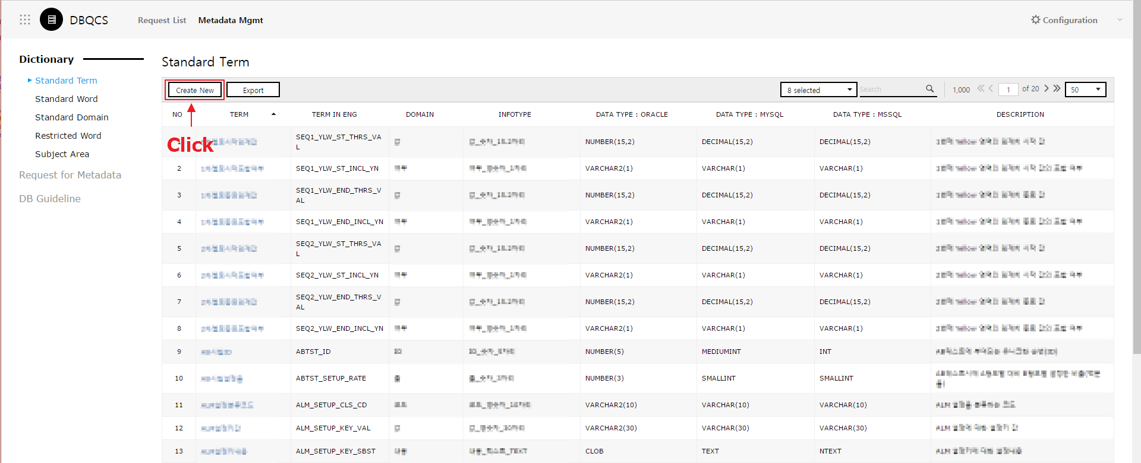

* + 1. Metadata can be exported as an excel file.

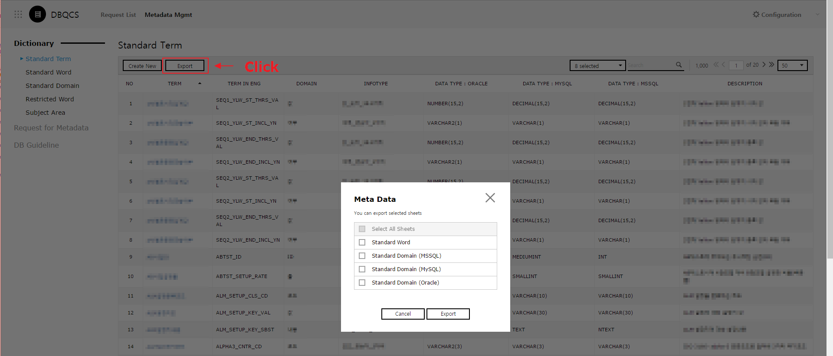

* + 1. Standard word can be used excluding the domain.

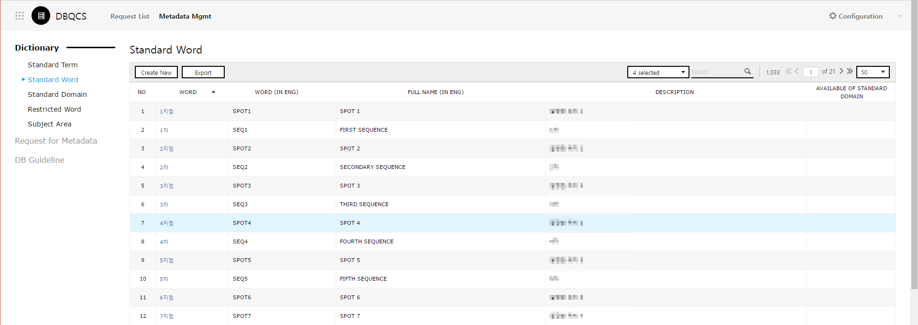

* + 1. The data type of standard domain can be set per Database Type.

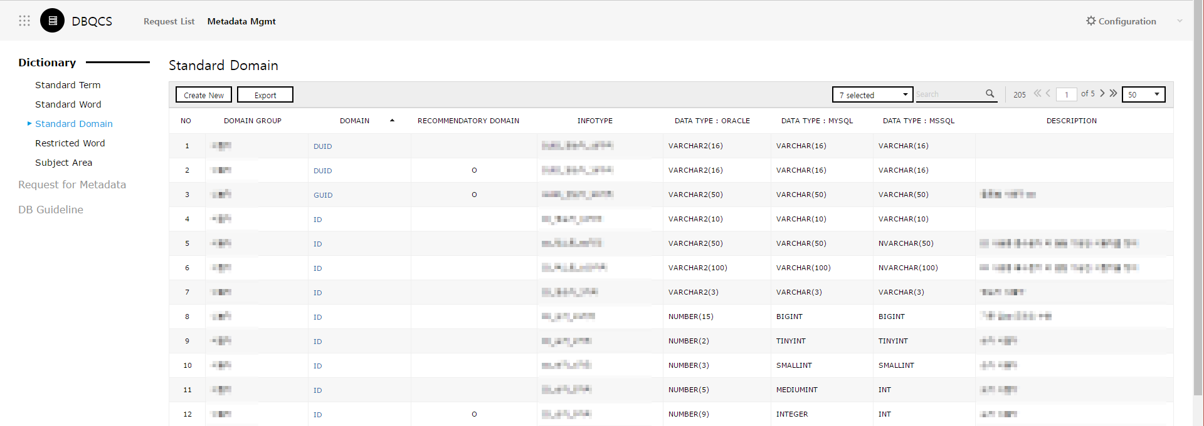

* + 1. Replaceable words as standard words can be set as banned words.

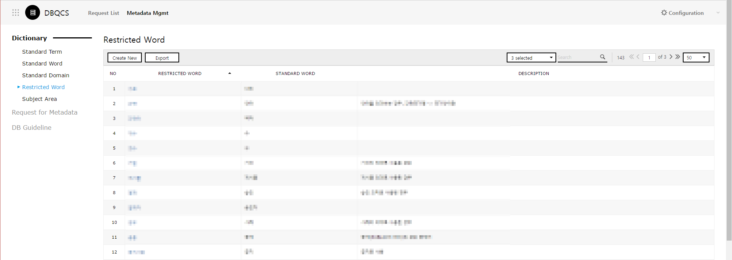

* + 1. You can compose the subject area to be used in the database.

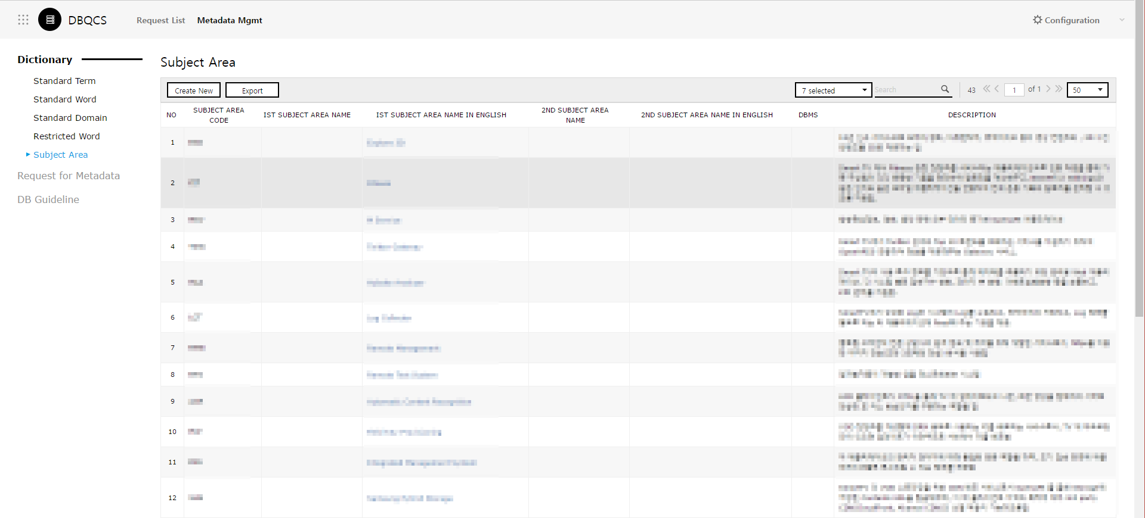

* 1. Request for Metadata
     1. You can make a request to add/edit/delete the metadata managed by Dictionary.

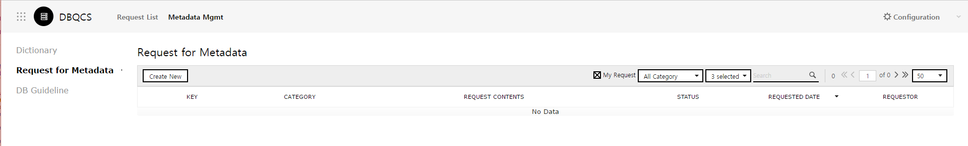

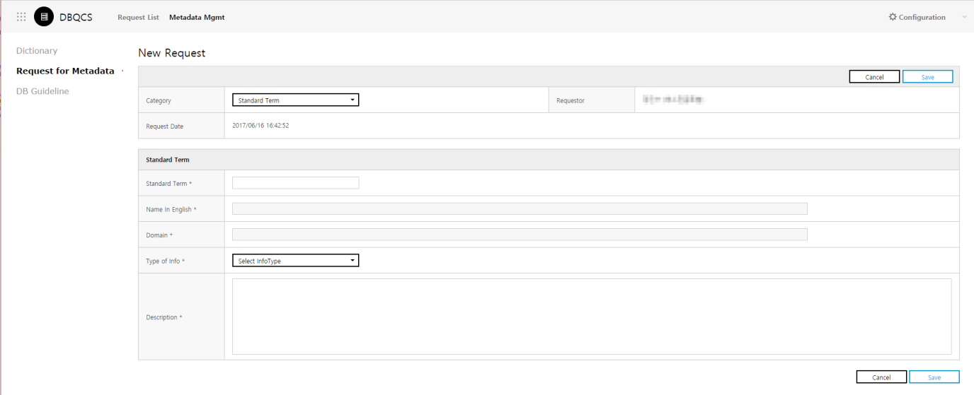

* 1. DB Guideline
     1. Manages the manual that includes standard policy and design guidelines used within the organization.

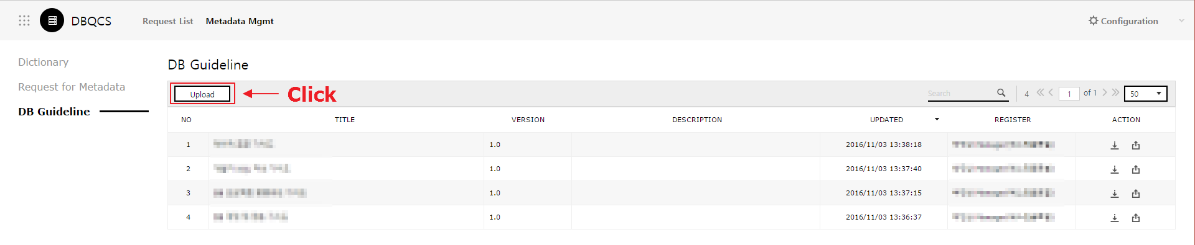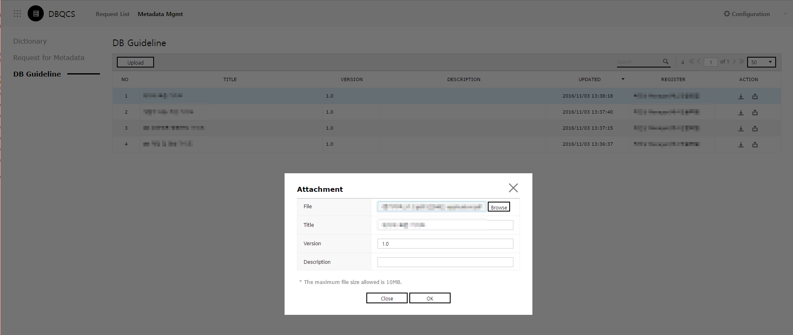

1. Request List
   1. You can manage request or inspection to improve DB function and quality.

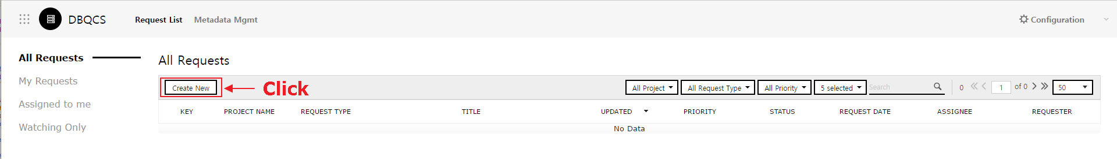

* 1. You can make a request with “Create New” button.

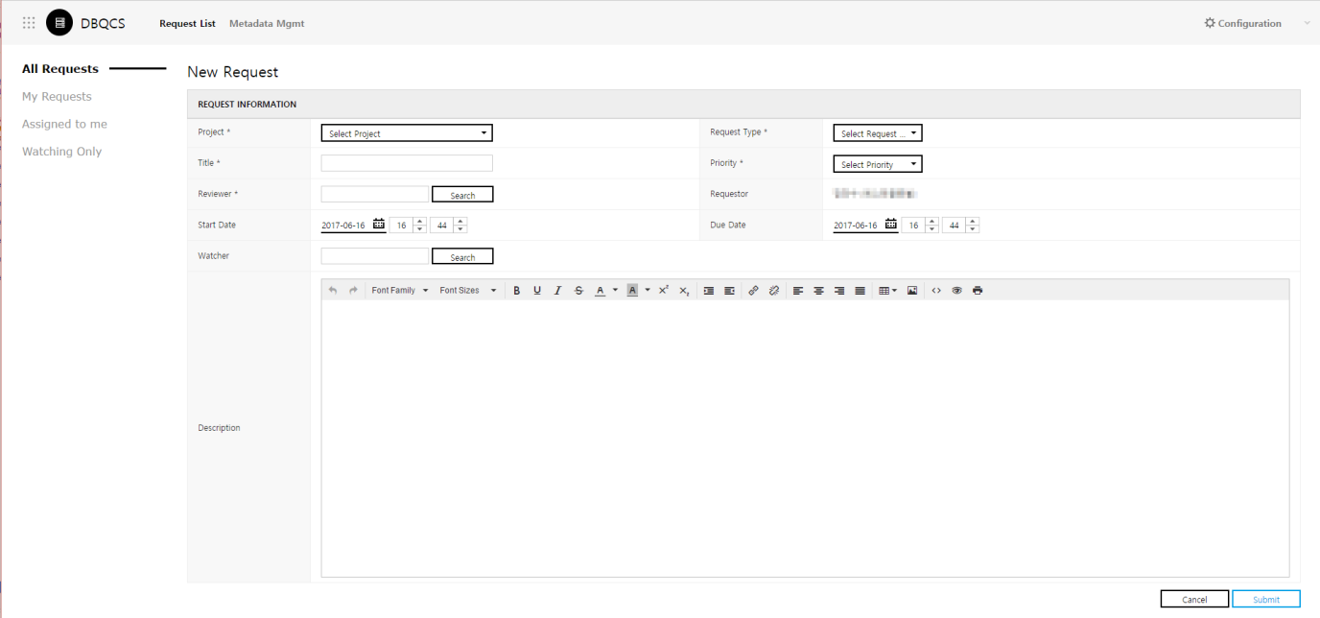

* 1. You can view All Requests/My Requests/Assign to me/Watching Only according to your intention.

